Fareast International University **

**Final lab reportSubmitted By: Submitted To:  
Name: Golam Morshed Bhuiyan Name: Ahmed Shafkat   
ID: 18120013 Designation: Lecturer  
Course: Artificial Intelligence   
Course Code: CSE-3115**

**Introductions**

Basically I will discuss logical programming here and show the output of different programs with prolog logical programming language. Prolog is a knowledge based (fact & rules) programming language. In a word it’s a declarative programming language.

**Problem 01: How to declare fact with output in prolog?**

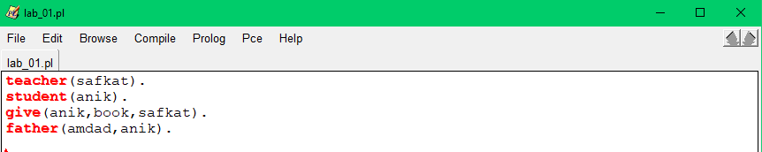

**Explanation of the code:** Here are some fact’s declared like, teacher(safkat). student(anik). give(anik,book,safkat). father(amdad,anik). If we think the essence of these, then the sentence’s will be like this-

Safkat is a teacher, Anik is a student, Anik gave the book to Orin, Amdad is a anik’s father.

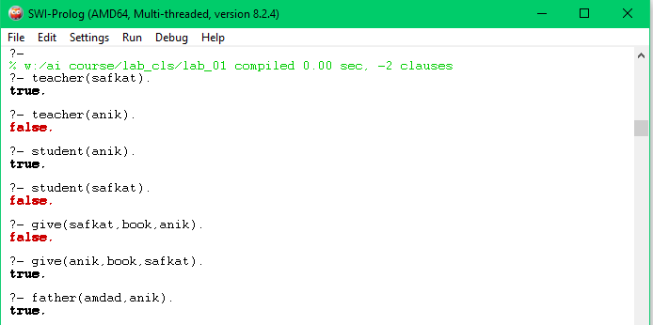

**Problem 02: How to declare variable in prolog?**

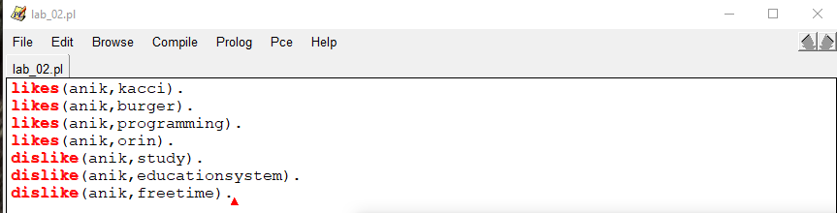

**Explanation of the code:** Here are some facts. I will display the output of these facts through variable. We need uppercase letter for variable like X,Y,Z or Cse, Eee, EEE,CSE etc otherwise will not be considered a variable. Number or others symbol not allow for declare a variable.

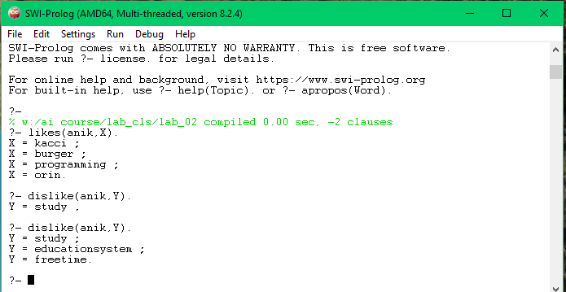

**Problem 03: How to use and & or operator in prolog?**

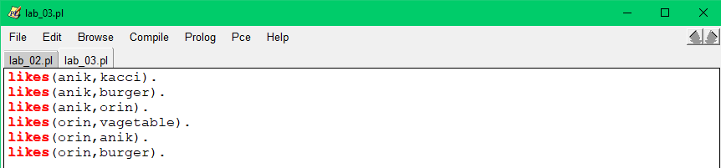

**Explanation of the code:** First I took the input some facts. Then I will show through the output how to use AND & OR operator in prolog.First I will check those facts whether they are true or false by using AND & OR operator. Then use AND & OR operator with variable.

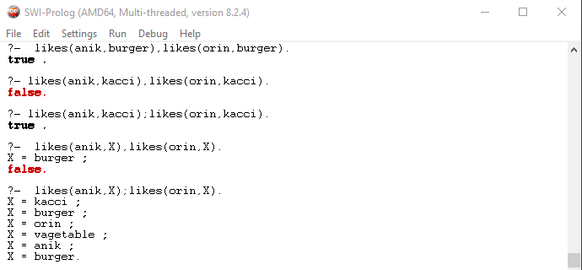

**Problem 04: How to use anonymous variable in prolog?**

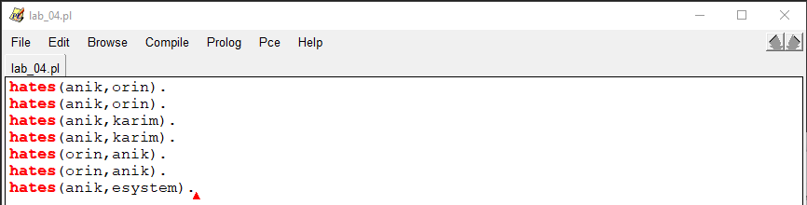

**Explanation of the code:** I input here some facts, then I checked all facts whether it true or false using anonymous variable. Anonymous variable declare symbol is ‘_’ . If we want to use anonymous variable in prolog then we have to start by this symbol.

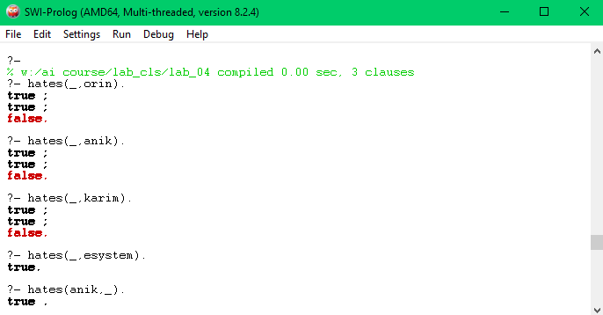

**Problem 05: How to use rules with if statement in prolog?**

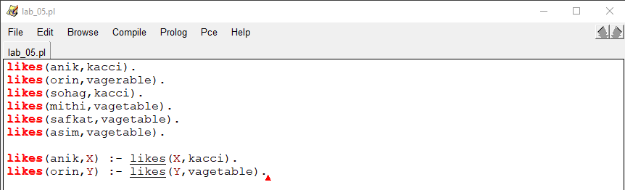

**Explanation of the code:** Here I used some facts with rules & also if statement. Some of the output displayed through the rules with statement of this program. It is mandatory to write rules, declare variable & add if statement which looks exactly like this - likes(orin,Y) :- likes(Y,vagetable).

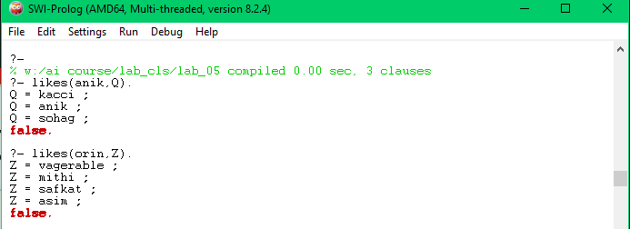

**Problem 06: how to implement tree with functions in prolog?**

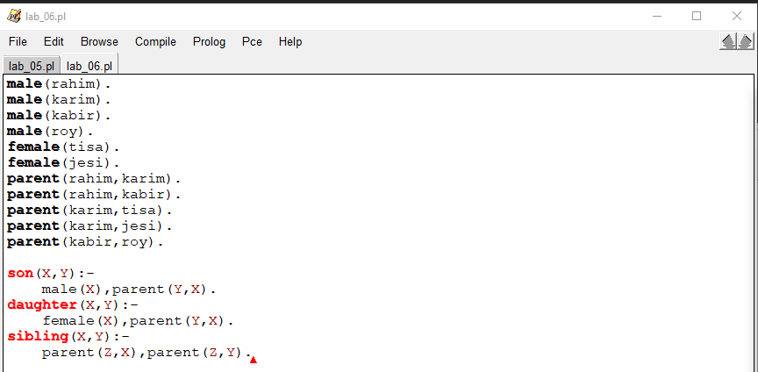

**Explanation of the code:** First of all I have taken some input facts here then i have declared some functions with statement which I can verify the authenticity of the above facts.

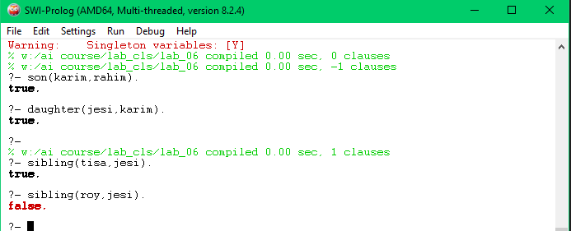

**Learned from the lab**

I learned about declarative programming / logical programming from this lab & also basic prolog.

**Conclusion**

In this lab report I have discussed some of the basics of declarative programming / logical programming with prolog and run the programs.